Technical Design Document for Replace with Your Product

Replace with Your CLC Group Members

Grand Canyon University: CST-326

Replace with Due Date

**Introduction**

*Replace with a short introduction to your product*.

**Scope**

*Replace with a brief description of what data this document contains.*

**The remainder of this is an incomplete example of a large, fictitious self-check project to illustrate the type of discussion and figures you may want to consider adding to your technical design document. The sections in this document should have a similar organization to the sections in your Requirements Document. This promotes traceability between the requirements and technical design. The Technical Design Document describes “how” the programmer needs to implement the requirements. Use this as an example for guidance. Your project details will be different. Remember, both the Requirements Document and Technical Design Document will contain more data than you can implement when you write your software. There may also be sections that are incomplete. (Agile allows for that.) Use the Agile-based tool to identify all the requirements and design data that need to be created or implemented in the product backlog. Your team will be learning to prioritize and manage risk while producing an application that can be demonstrated and tested.**

**Functional Description**

The SSR-100 is a common hardware platform that will work in any retail or grocery store setting. The SSR-100 software is customized to meet the specific needs of the customer. The following subsections provide technical details for the SSR-100 software.

**Architecture**

The SSR-100 for GRM is consists of a Point of Sale (POS) scanner, an attendant device, and a Verifone device used to process debit and credit card transactions. The architecture is shown in Figure 1. For the GRM implementation, the Management and Employee Device is being deferred to a later Sprint.



Figure 1 SSR-100 Architecture for GRM

**Attendant Device**

TBD – Discuss the attendant device functionality.

**Self-Check Station**

The Self-Check Station, called the POS Scanner, is the interface to the customer. When turned on, the customer will see a Welcome User Interface (UI). This will allow the customer the option to begin scanning or call the attendant and ask any questions they may have. The initial UI is shown in Figure 2.

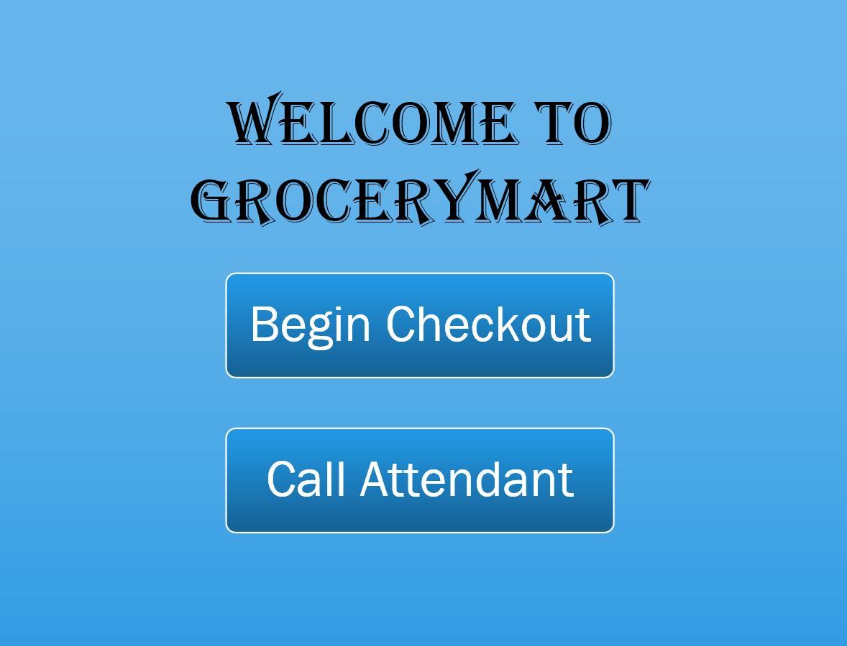

Figure 2 SSR-100 Welcome UI

If the customer selects Call Attendant, the Call Attendant UI in Figure 3 is displayed. Once displayed, the attendant is notified on the Attendant Device and the customer cannot continue with any activities until the attendant clears the call.

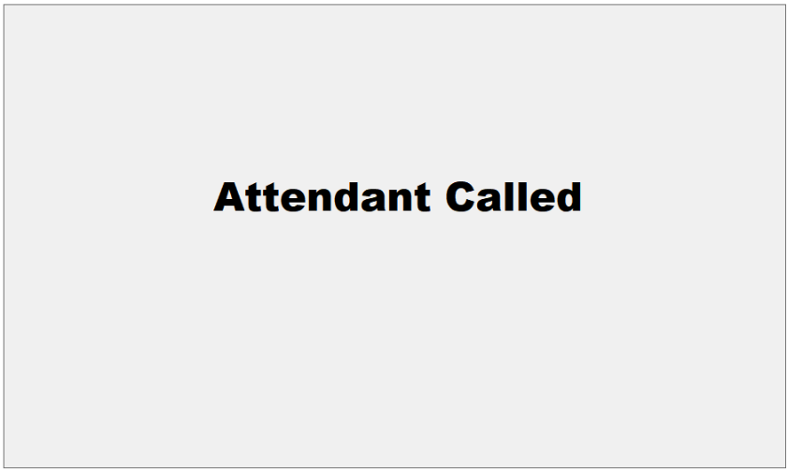

Figure 3 SSR-100 Call Attendant UI

If the customer selects Begin Checkout, the process of scanning, bagging, and paying for their purchases begins. This is referred to as the Customer Transaction. When Begin Checkout is selected, the UI in Figure 4 is displayed to the customer.

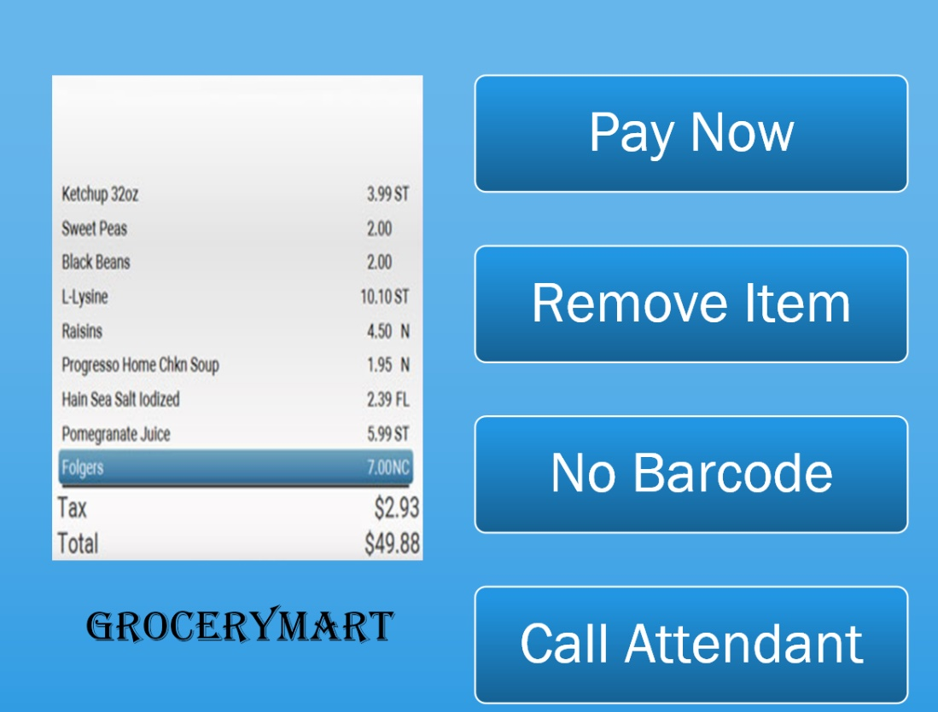

Figure 4 SSR-100 Checkout UI

The customer will continue to scan items and place them in the bag or cart until they are ready to pay. If a restricted item is scanned, the Call Attendant UI is displayed and the attendant will clear the call after checking the customer’s identification to ensure they meet the age restriction for the item being purchased. Restricted items consist of cold medication, alcohol, or tobacco. Grocerymart is required by state law to verify the purchase of restricted items. See Figure 5 for the expected state flow for a normal Customer Transaction.



Figure 5 SSR-100 Customer Transaction State Diagram

When the customer selects Pay Now, the UI in Figure 6 is displayed. The customer will then select a payment method.

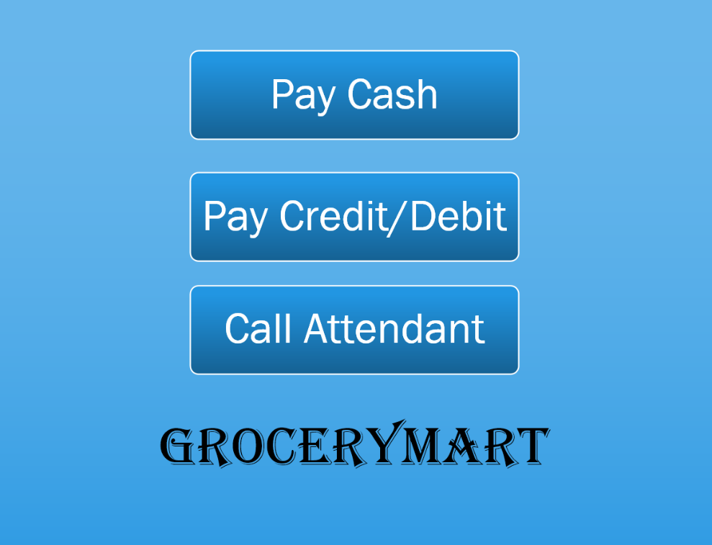

Figure 6 SSR-100 Pay UI

TBD – Discuss Pay Cash

If the customer selects Pay Credit/Debit, Verifone is used to process the financial transaction. Verifone is connected by USB to the POS Scanner and Verifone uses a phone line to complete the transaction. Once payment by credit card or debit card is selected, Verifone controls the transaction sequence. Refer to Figure 7 and Figure 8 for the debit and credit card pay sequence diagrams.



Figure 7 Customer Debit Payment Sequence



Figure 8 Customer Credit Payment Sequence

**Databases**

*Add technical details.*